John Michael Go
Career Entry Level Java Programming
Date: Jan. 22, 2013

DAY 8

Program Name: MultiArray

Objective: This is a program for multi-dimensional array.

Algorithm:

1. Program outputs values from a 2 dimensional array.

Flowchart:

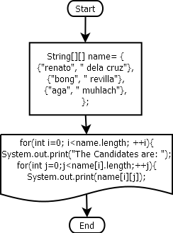

Pseudocode:

public class MultiArray {

public static void main(String[] arg) {

String[][] name= {
{"renato", " dela cruz"},
{"bong", " revilla"},
{"aga", " muhlach"},
};
for(int i=0; i<name.length; ++i){
System.out.print("The Candidates are: ");
for(int j=0;j<name[i].length;++j){

System.out.print(name[i][j]);
if (j<2)
System.out.print("");
}
System.out.println("");

}

}
}

Screenshots:

